Result, conclusion and future research

Result

Table for evaluation

Conclusion

By using pre-trained model, we are able to detect face and alignment for in the pre processing step. Besides, during experiment, we briefly understand about caffe model and our future work. By using Graphic User Interface, we designed a system that matches two faces: on ID card and the student himself. See Fig 1 2 3

Future work

In future work, we consider that changing our system into Face Verification for Organizations by design a database of staffs and wireless connection through Microcomputer.

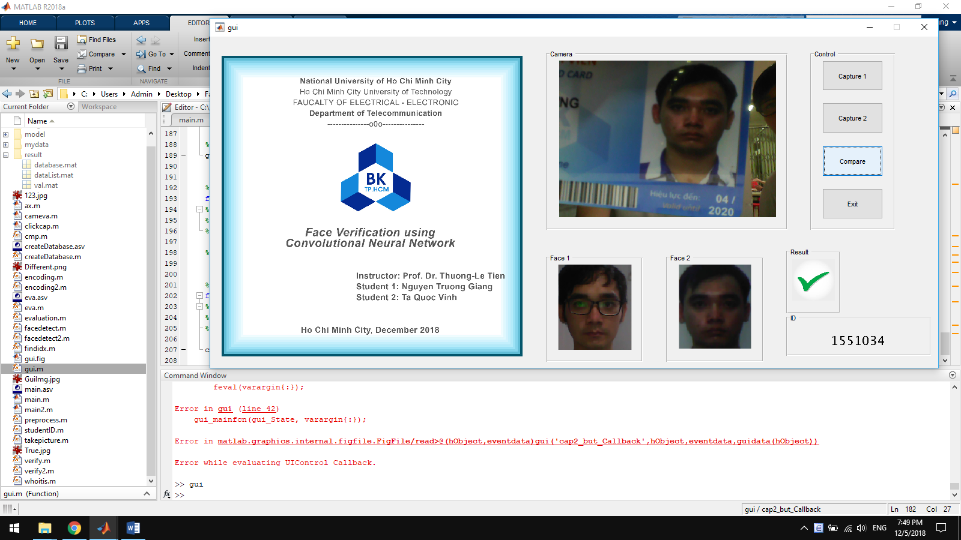

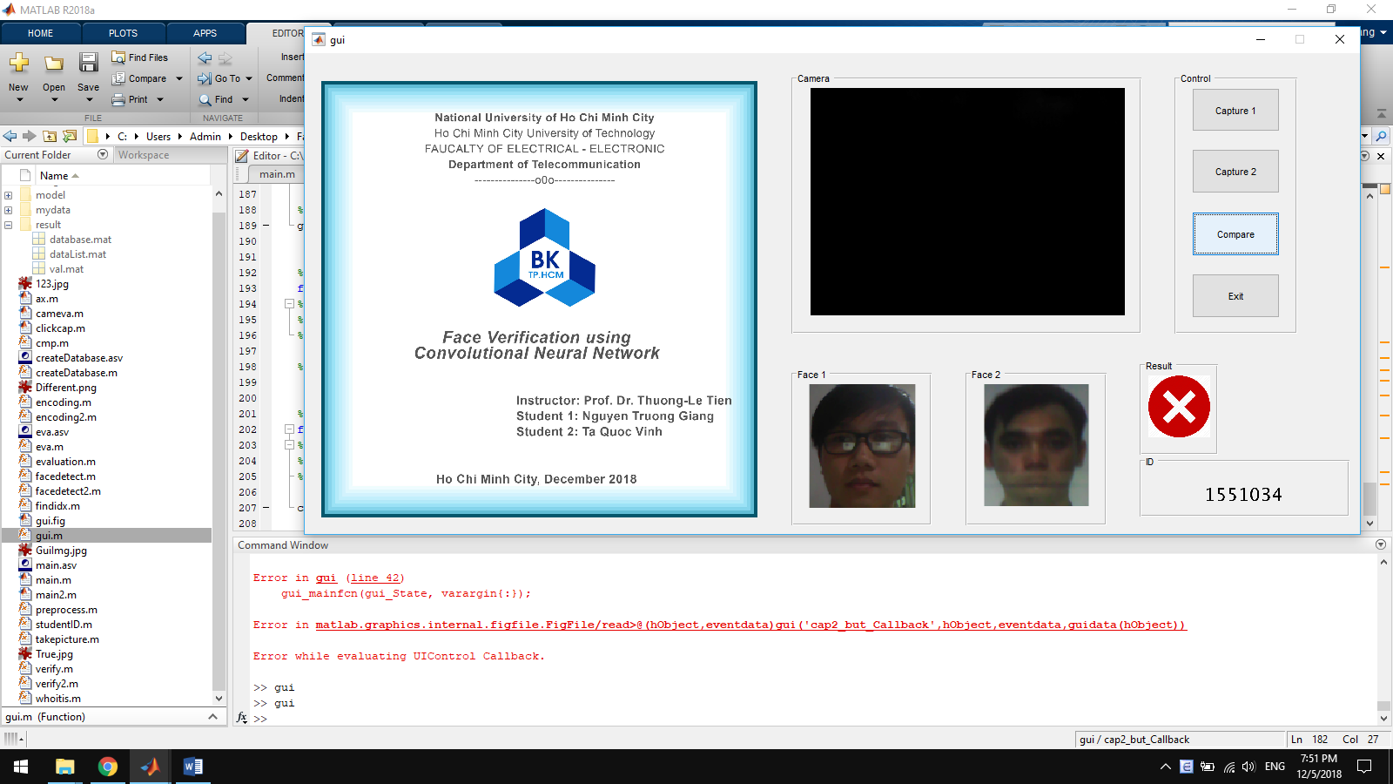

After doing the software project, our system can distinguish two images input whether that is the same person or not. By capturing the images by snapshot camera of laptop then encode the images to recognize the faces and calculate the normalization of these vectorization of inputs, we can verify the faces and the ID students on the ID student cards partially complete. The evaluation of our projects is approximately more than 96%, (table eva).

Using GUI (Graphic User Interface), we designed the interface suitably and observable. (figures).

Eva

By using GUI integrated with MATLAB ( fig.), we are able to make an application which can:

\begin{enumerate}

\item Capturing and detect student's face.

\item Capturing their ID card.

\item Detecting ID number on the card.

\item Detecting face on ID card.

\item Matching whether two detected face is from one person.

\end{enumerate}

As the main purpose we set on this project

And to evaluate our project, by collecting picture of lost ID card and matching with their daily life’s picture, we are able to set up the following table:

|  |  |  |
| --- | --- | --- |
| Size | Student ID accuracy | Face Verification accuracy |
| 10 | 90% | 100% |
| 20 | 95% | 100% |
| 30 | 86.67% | 96.6667% |
| 40 | 92.5% | 97.2973% |

From the result above we can have some general conclusion that:

* Our method work correctly in most of the case.
* The failure of ID number detection is because of the holding card position need to be fixed.
* Picture need to be taken with enough light.
* Picture must not be edited before the process.